DISCUS QUICK REFERENCE GUIDE
Safety tips
- Make sure all helpers and other athletes not throwing, stand outside of the cage while a throw is in progress.

Equipment Needed | SETUP – Officials
- Tape measure  - Assorted discus  - Spike for marking  - Sector line markers/flags | - One parent on measuring spike  - One parent to measure distance & check for foul throws  - One parent to marshal athletes & record measurements

Discus Weights
Age Group | Weight (grams)
U7 Girls & Boys | 350
U8-U11 Girls & Boys | 500
U12-U13 Girls & Boys | 750
U14-U16 Girls & Boys | 1000 or 1kg

Number of Throws
- Each athlete will have 3 throws, normally one at a time. However, an athlete may take 3 throws consecutively, with only the best throw measured.
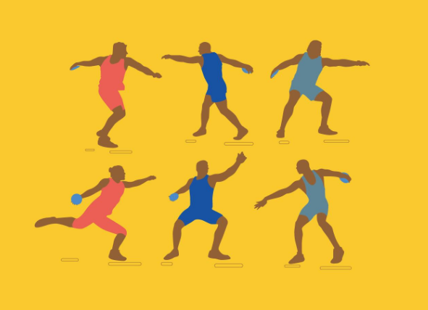
Valid Throw
- The throw must be commenced from a stationary position inside the circle.
- The athlete must not leave the circle until the discus has landed.
- The athlete must not touch the top of the circle or the ground outside the circle during the throw with any part of their body. They are allowed to touch the inside of the circle.
- For a valid throw, the discus must fall so that the point of impact is within the inner edge of the lines marking the sectors.
- The athlete may enter the circle from any direction (preferably from the rear half of the circle) but must exit from the rear half of the circle.
- The athlete may during the course of each throw, stop and place the discus down in the circle and then recommence the throw again, providing that no other infringement has occurred.
- Once competition has begun, athletes shall not be permitted to use the circle or ground within the sector for practice throws with or without implements.
Method of Measurement
- Officials select the imprint mark made by the discus.
- The selected point is marked by the spike and the zero end of the tape is held at the spike.
- The tape is drawn tight through the centre of the circle.
- The distance is measured at the point where the tape crosses the inner edge of the circle.
- Each measurement is to the nearest cm below the distance thrown.
- If the discus hits the cage and deflects back into the sector it shall be a valid trial and measured providing no other infringement occurs.

Recording
X should be used to indicate an Invalid Throw
Athlete | 1st Throw | 2nd Throw | 3rd Throw | Best | Place
A | 14.75 | X | 14.62 | 14.75 | 3
B | 15.35 | 14.92 | 15.88 | 15.87 | 1
C | 14.65 | 14.35 | 24.75 | 14.75 | 2
D | X | X | X | NM | NM

- Results will always show “NM” when an athlete fails to record a measurable trial.

